SmartHire-AI
AI-Powered Mock Interview and Candidate Assessment Platform

Live deployment: https://smarthire-ai-1-1f6o.onrender.com/

1. Objective
Build an AI-powered mock interview and candidate assessment platform that helps candidates prepare for technical, HR, behavioral, and aptitude interviews through automated interview simulations, speech analysis, confidence evaluation, and AI-generated feedback.
The system allows candidates to participate in AI-driven interview sessions with webcam and microphone support, receive personalized assessments, track performance trends, and improve interview readiness through actionable recommendations.
The platform supports interview preparation, candidate evaluation, communication skill enhancement, and performance analytics using artificial intelligence and real-time monitoring, for use by students, job seekers, training institutes, recruitment agencies, universities, and corporate hiring teams.

2. Outcomes
Status against the original outcome goals, based on the delivered and deployed codebase:
- Developed and deployed an AI-powered mock interview platform (frontend + two backend services, containerized, live on Railway).
- Implemented secure authentication and role-based access control (JWT + Google OAuth; candidate, recruiter, coach, admin roles).
- Built resume upload and AI-based skill extraction workflows (resumeEngine.js: skills, technologies, experience, education, summary).
- Developed AI-driven interview question generation systems (question_bank.py, ai_providers.py — multi-provider: Ollama, Gemini, OpenAI, Grok).
- Implemented speech-to-text transcription and communication analysis (communication_analysis.py).
- Built confidence evaluation and webcam-based eye-contact/attention monitoring (face-api.js proctoring pipeline).
- Developed AI-powered scoring and candidate assessment workflows (scoring_engine.py, weighted rubric).
- Created dashboards for performance tracking and interview analytics for every role (analytics.py).
- Generated personalized feedback and improvement recommendations (scoring + notification engines).
- Deployed the platform using Docker, live in production on Railway.
Two outcomes were delivered differently than originally scoped — see Section 7 (Tools & Tech Stack) for detail: the backend was split into a Node.js/Express service and a Python/FastAPI service rather than one Django/FastAPI service, and a fourth role, coach, was added alongside candidate/recruiter/admin.

3. Architecture
Four containerized services, coordinated by Docker Compose and deployed to Railway:
Service | Technology | Port | Responsibility
frontend | Static HTML/CSS/JS via nginx | 5500 → 80 | Candidate / recruiter / coach / admin UI, login & registration, interview session UI, coding practice UI
backend | Node.js + Express | 5000 | JWT + Google OAuth auth, users, resumes, job openings, notifications, settings
backend-python | Python + FastAPI | 8001 | AI interview engine, question generation, scoring, coding judge, analytics, TTS, email
db | PostgreSQL 16 | 5432 | Shared database for both backend services
Both backend services read/write the same PostgreSQL database and share one JWT secret so tokens issued by either service are honored by the other.

4. Workflow
It's a website where a candidate can practice job interviews with an AI interviewer — the AI asks questions, listens/reads the answers, scores them, and gives feedback — while admins, coaches, and recruiters have their own dashboards to manage and review candidates. Everything else in this report is detail supporting that one idea.
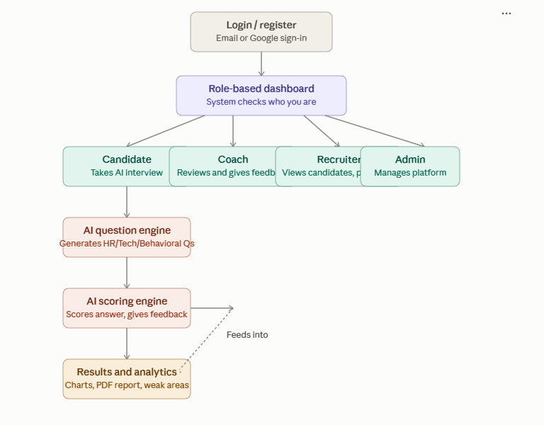
That's the whole platform in one picture: login → role check → each role gets a different dashboard, and the candidate's path feeds the AI engine, which scores answers and produces results. Now zooming into what happens inside a candidate's interview — usually the part that stands out most, since it's the "AI" part:
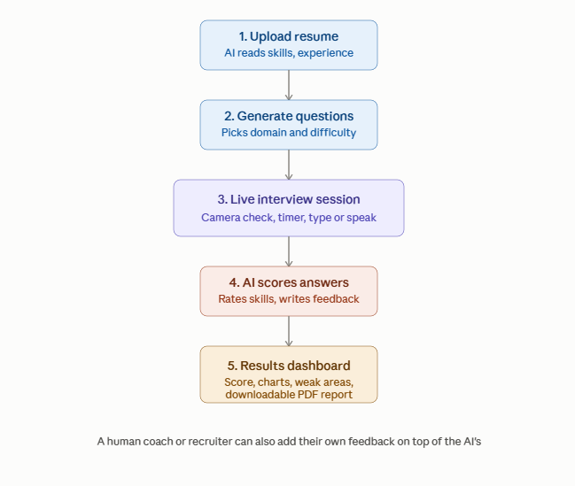

5. Modules Implemented

1. User Authentication & Role-Based Access
- JWT authentication, Google OAuth2 login, session handling, secure account management, bcrypt-hashed passwords.
- Candidate: upload resumes, attend mock interviews, view interview history, access performance analytics, download reports, track improvement progress.
- Recruiter: review candidate analytics, access candidate reports, compare candidate performance, create interview templates, monitor interview sessions.
- Coach: assigned-candidate list and today's coaching schedule, leaves review feedback on completed interviews (bonus role beyond the original plan).
- Admin: manage users and recruiters, configure platform settings, monitor system activities, manage AI configurations, access platform-wide analytics.

2. Resume Upload & Skill Extraction
- PDF resume upload (≤8MB), text extracted server-side with pdf-parse.
- Skill extraction — keyword matching against a curated technology dictionary.
- Technology detection — the same skills categorized into languages / frameworks / databases / cloud & DevOps / tools.
- Experience parsing — an explicit "X years experience" phrase if present, otherwise summed from detected role date ranges.
- Education analysis — degree keywords (B.Tech, MBA, M.Sc, …) matched against the education section, paired with the nearest year.
- Resume summary generation — a short paragraph assembled from the above, plus stored/re-downloadable original PDFs.

3. AI Interview Generation
- Multi-provider AI engine with automatic fallback so one rate-limited key never breaks the app: Ollama (free, local) → Gemini (rotates across multiple keys) → OpenAI → Grok.
- No provider configured still works — falls back to a curated question bank and a randomized-but-plausible scoring simulator.
- Interview types: HR, Technical, Behavioral, Aptitude, and Mixed (spread evenly across all four).
- Domain customization for Technical questions (Java, Python, Frontend, Data, …), selectable difficulty (easy/medium/hard), configurable question count (1–20), online/offline mode.
- Recruiters can save named interview templates that pre-fill this form for candidates.

4. Interview Session Management
- Webcam- and microphone-based live session interface.
- Per-question countdown (90/120/150 seconds by difficulty) plus a running total-session timer.
- Candidates answer by typing, by voice (Web Speech API, transcribed live and editable), or both; each answer autosaves as the candidate progresses, so a reload doesn't lose work.
- Full session lifecycle: start now, schedule for later, attend a scheduled session, cancel, edit or regenerate a not-yet-completed session's questions.
- Session and answer records persisted for scoring, review, and history.

5. Speech-to-Text & Communication Analysis
- Real-time speech transcription of candidate answers.
- Grammar checking, filler-word detection, speech-pace analysis, pronunciation evaluation, and an overall communication-quality assessment.
- Feeds directly into the Communication score (30% weight) in the scoring engine.
- Question audio delivered via text-to-speech — gTTS is the primary engine, with an automatic offline fallback to pyttsx3 when there's no internet; audio is cached per question after first generation.

6. Emotion Detection & Eye Tracking
- Client-side face detection roughly every 1.5 seconds (face-api.js) — flags no face, more than one face, or looking away from the screen.
- Tab-switch, window blur, full-screen exit, and blocked copy/paste are all logged as proctoring violations.
- Five violations auto-submits the interview; staff (coach/recruiter/admin) are alerted when a live session's violations hit 3 and 5.
- These signals feed the Confidence score (25% weight) in the scoring engine.

7. AI Feedback & Scoring
The platform evaluates candidate performance using a weighted rubric built from the signals collected during the session:
- Communication (30%): speech clarity, grammar quality, filler-word frequency, speaking pace, response completeness.
- Confidence (25%): eye-contact consistency, facial engagement, response hesitation, speaking confidence, attention level.
- Technical Relevance (30%): technical accuracy, keyword relevance, problem-solving ability, domain knowledge, answer completeness.
- Professionalism (15%): time management, response organization, professional communication, interview etiquette.
Overall Score = (Communication × 30%) + (Confidence × 25%) + (Technical Relevance × 30%) + (Professionalism × 15%)
- Rating bands: 90–100 Excellent · 75–89 Good · 60–74 Average · 40–59 Needs Improvement · below 40 Poor.
- Auto-generated strengths, weaknesses, improvement suggestions, practice recommendations, and learning resources.
- Scoring is grounded in the candidate's actual transcript when a live AI provider is available, and falls back to a randomized-but-plausible simulator otherwise.

8. Coding Practice & Judging
- Standalone from the scored live-interview flow; a candidate's role locks which programming language they practice in.
- Candidate submits code against a curated problem's test cases; graded purely algorithmically by exact stdin/stdout match — never AI-judged.
- Every graded attempt is saved to submission history, exportable as a PDF or Excel score list.

9. Notifications & Reports
- In-app and email notification feed, per-user or broadcast to a role.
- Automated interview reminders — scans upcoming scheduled interviews and sends a one-time in-app + email reminder, triggerable on a schedule (cron).
- Session alerts notify admins when a live session's proctoring violations hit 3 and 5.
- Downloadable per-interview PDF report, plus an aggregate performance-summary PDF across every completed interview.
- Append-only activity/audit log for admin monitoring of system activity.

10. Dashboard & Analytics

Candidate Dashboard
- Overall performance score
- Interview history
- Score breakdown
- Skill-wise analytics
- Weak-area identification
- Performance trends
- AI feedback & improvement progress
- Download reports

Recruiter Dashboard
- Candidate performance overview
- Candidate profiles & reports
- Candidate comparison
- Skill-wise analytics
- Candidate ranking
- Performance trends
- Shortlisting insights

Admin Dashboard
- User & recruiter management
- Interview activity monitoring
- AI performance monitoring
- System activity/health reports
- Platform usage analytics

11. Final Integration, Testing & Deployment
- All four services (frontend, Node backend, Python/FastAPI backend, PostgreSQL) integrated and containerized via docker-compose.yml.
- CI pipeline under .github/workflows; Jest (Node) and Pytest (Python) test suites.
- End-to-end testing across the full candidate journey: login → resume upload → AI-generated interview → proctored session → scoring → dashboard/reports.
- Deployed to production on Railway — https://ai-interview-frontend-production-513a.up.railway.app/. Railway's service filesystem is ephemeral, so a mounted volume was added to persist interview recordings across deploys/restarts.
- Setup and usage documented in README.md and DEPLOYMENT.md.

6. Evaluation Criteria — Status

Milestone / Area | Status
Backend initialization, auth workflows, database schema, frontend setup | Complete — Express backend, FastAPI service, Postgres schema, nginx-served frontend
Resume upload/parsing, AI interview generation, session workflow | Complete — resumeEngine.js skill extraction, ai_providers.py + question_bank.py, interview session CRUD
Speech/communication analysis, emotion & eye tracking, scoring engine, feedback generation | Complete — communication_analysis.py, face-api.js proctoring, scoring_engine.py, notify.py
Dashboard & analytics (candidate / recruiter / admin), notifications & reports | Complete — analytics.py, role-specific dashboards, PDF/Excel exports, email + in-app reminders
Full integration, testing, and production deployment | Complete — docker-compose.yml (4 services), Jest + Pytest suites, live on Railway

7. Tools & Tech Stack
As actually used in the delivered and deployed codebase (differs from an original Django-based plan — see Section 2):
Layer | Technologies
Frontend | HTML, CSS, JavaScript, face-api.js, Web Speech API, served via nginx
Core API | Node.js, Express, JWT, Passport (Google OAuth), pg, multer, pdf-parse
AI Service | Python, FastAPI, SQLAlchemy, Pydantic, gTTS / pyttsx3, reportlab, openpyxl
Database | PostgreSQL 16 (Docker), psycopg2
AI providers | Ollama, Gemini, OpenAI, Grok (multi-provider fallback chain)
Testing | Jest (Node), Pytest (Python)
DevOps & Deployment | Docker & Docker Compose, GitHub Actions, Railway (production hosting)

8. Performance Metrics (Tracked Areas)

Interview Analysis
- Speech transcription accuracy, emotion/confidence signal quality, session recording reliability.

AI Scoring
- Communication / technical relevance scoring accuracy, feedback consistency, assessment reliability.

Analytics
- Dashboard response time, report generation performance, data processing efficiency.

System
- API response time, concurrent interview session handling, database query performance.

9. Quantitative Goals

Interview Analysis
Accurate speech transcription and interview behavior monitoring.

AI Assessment
Reliable communication, confidence, and technical evaluation scores.

Feedback Generation
Actionable interview improvement recommendations.

Platform Performance
Support multiple concurrent interview sessions with stable performance and real-time analytics.

